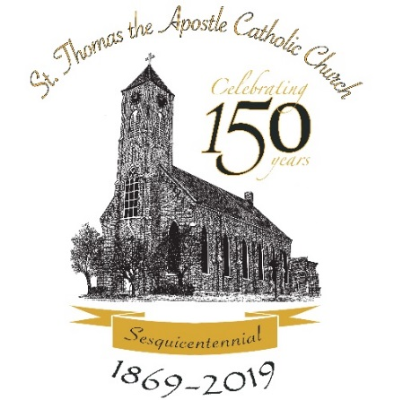

St. Thomas the Apostle

Parish Sesquicentennial

History Book Order Form
St. Thomas the Apostle Parish in St. Thomas, Missouri is pleased to announce the publication of a new history book celebrating the long history of Catholic faith, hard work and rural living of this community. A hardbound book of more than 500 pages will be published by Walsworth Publishing Company in time for the Parish Sesquicentennial Celebration on June 29, 2019. This keepsake book is now able to be pre-ordered for the special price of $45 before December 31, 2018. After that date, the price will be $50 per book. We hope you will want to own your own copy of this carefully researched and lovingly written commemorative book which is filled with hundreds of photos, parish history, military service, and family stories of past and present parishioners.
Books will be available for pick up at the Parish Office beginning in July 2019. (Kindly call 573-477-3315 to check Parish Office hours.) History books will be also be available at the Parish Picnic on August 18, 2019, at the Sesquicentennial Homecoming Event on October 6, 2019, or they can be shipped to you for $10 per book.

_____ Copies at $45.00 each: $_______ (if ordered by December 31, 2018)

_____ Copies at $50.00 each: $_______ (if ordered after December 31, 2018)

_____ Shipping and handling: $_______ (add $10.00 per book if wanting a book mailed to you)

Total amount enclosed: $_______

Contact/shipping information:

Name: ____________________________________________________________________

Address: ___________________________________________________________________
City: _____________________________________ State: ________ Zip Code: ___________

Phone: ___________________________

Email Address: _____________________________________________________________
Please make checks payable to:
St. Thomas the Apostle Church
P.O. Box 146
St. Thomas, MO 65076

